Registered with the Property Practitioner Regulatory Authority (PPRA)

08/08/2024

3 Strand Gardens
Vredenhof Road
Strand

Dear Ms M Bennett

Current Market Valuation: 3 Strand Gardens, Vredenhof Road, Strand

Thank you for the opportunity to assess the current market value of your property.
We provide true independent and impartial advice and are focused to achieve optimal results for our clients. The following items was considered to assess the market related value:

Condition

The overall condition of the property can be considered as a “move in and stay” property and just minor maintenance issues – Lounge Tiles are cracking.

Location

Property is located close to the shops, schools & public transport, with easy access to major routes such as N2 and very close to Beach

Security

Security Complex with access control gate, electrical fencing around the Complex, the property itself has security gate.

Comparative Market Analysis

We compare the prices of other properties that were sold in direct vicinity of the property and registered in the Deed’s office.

With the above taken into consideration, we advised that your property can be valued between R 1 241 000 to R 1 274 000 . We recommend marketing the property at the price of R 1 299 000 .

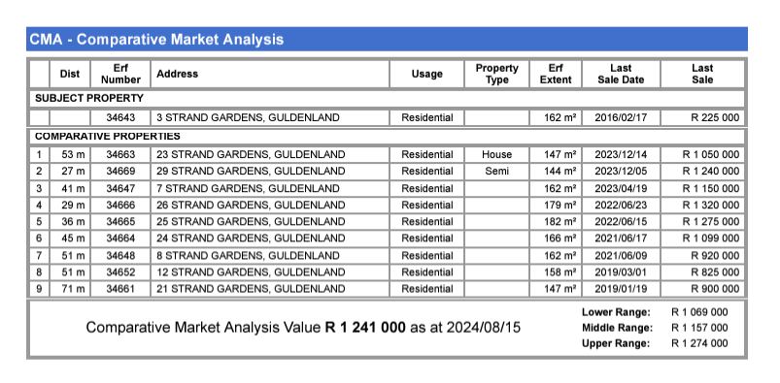

We, however can set the price according to your instruction, but will advise that this may exhaust valuable time and can overexpose your property to the market. It will be a privilege to market your property, should you decide to sell. Please do not hesitate to contact us if we can be of any further assistance.

Kind Regards
Chrissie & Willem Erasmus

